**Social LogIn Application**

**Requirement:**

Social web application by providing authentication with GitHub, linkedin and twitter.

1)Evert user login from different platform should be merged with mobile number

2)List of Api’s with:

i)Get All users

ii)Get by Id

iii)Search by mobile number

3)Admin portal

Technical Requirements:

1)Django 2.2

2)python-social-auth-0.2

3)LinkedIn, Twitter, Github developer apps

Setup:

1)Migrate database tables(python manage.py makemigrations --> python manage.py migrate)

2)Create super user (python manage.py createsuperuser)

Status of requirement:

1)Login via social platfrms:

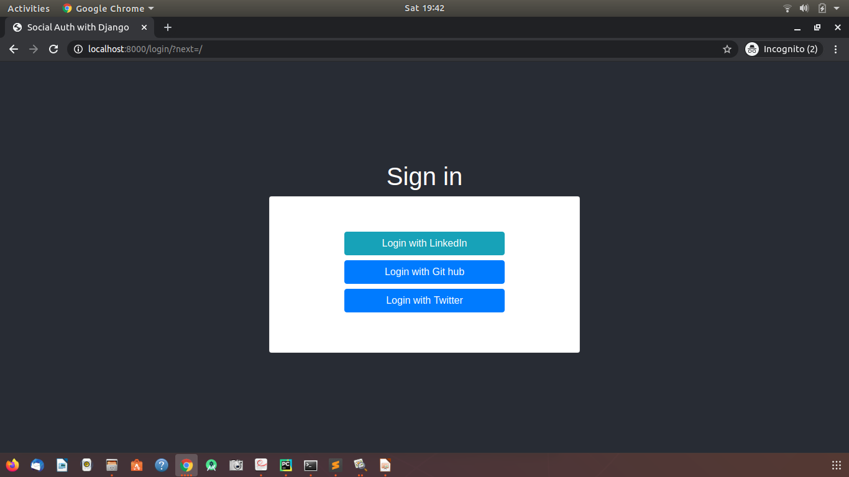

For social authentication, used python-social-auth 0.2 to interact with all platforms.

i)LinkedinOAuth2

ii)GithubOAuth2

ii)TwitterOAuth

After login showing user name and login platform:

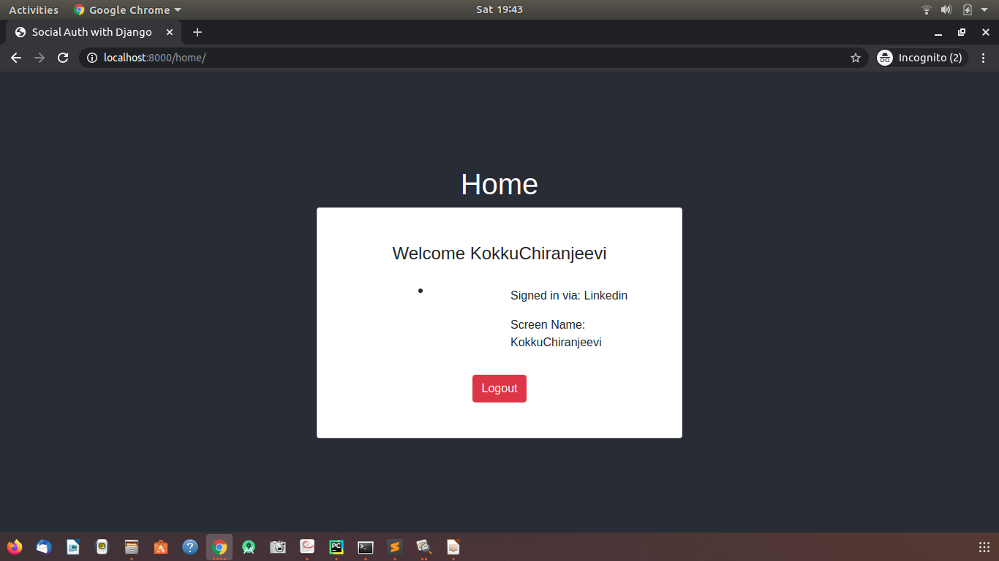

2)API’s for users, filter by id and

i)GET /user/all:<http://localhost:8000/user/all/>

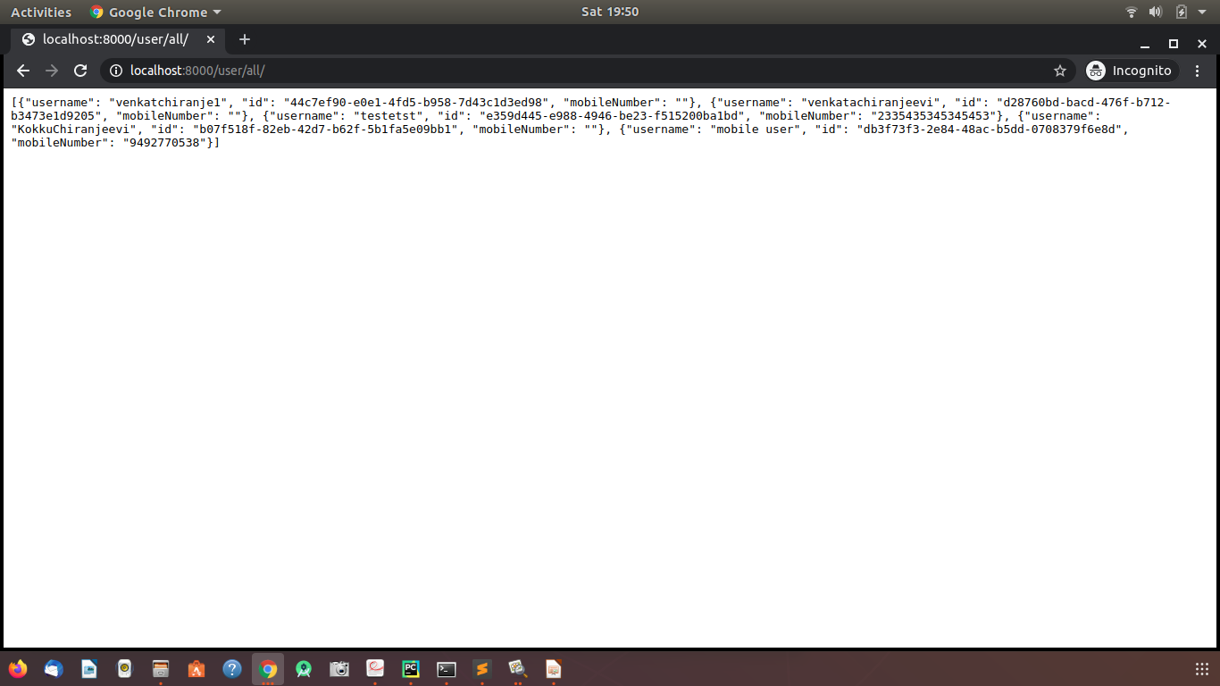

ii)Get by user id: <http://localhost:8000/user/id/?userid=44c7ef90-e0e1-4fd5-b958-7d43c1d3ed98>

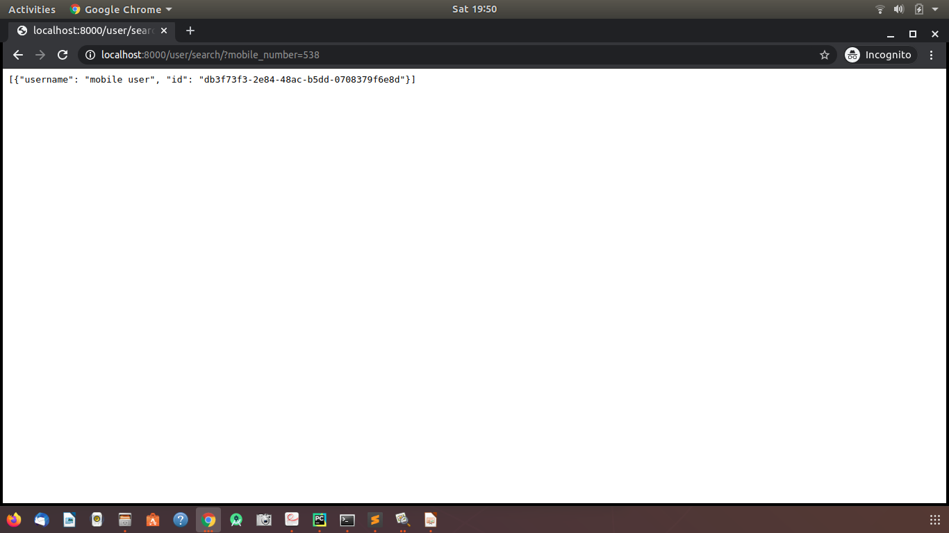

iii)Search by mobile number:

<http://localhost:8000/user/search/?mobile_number=538>



3)AdminPortal:

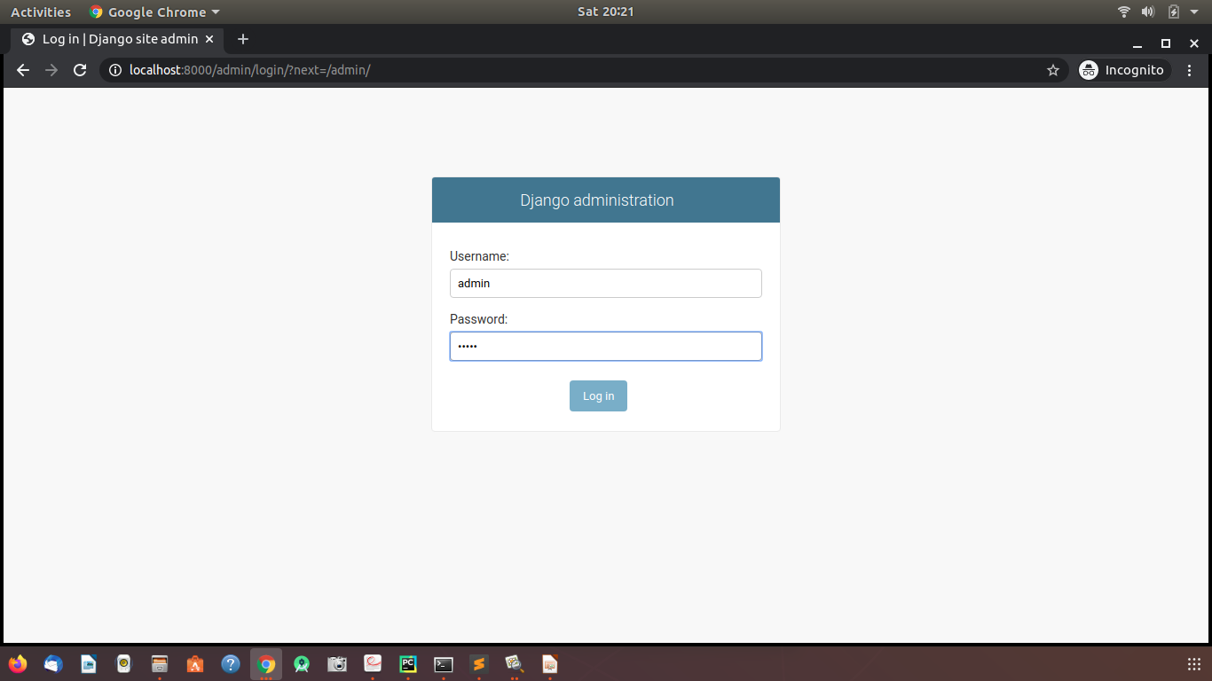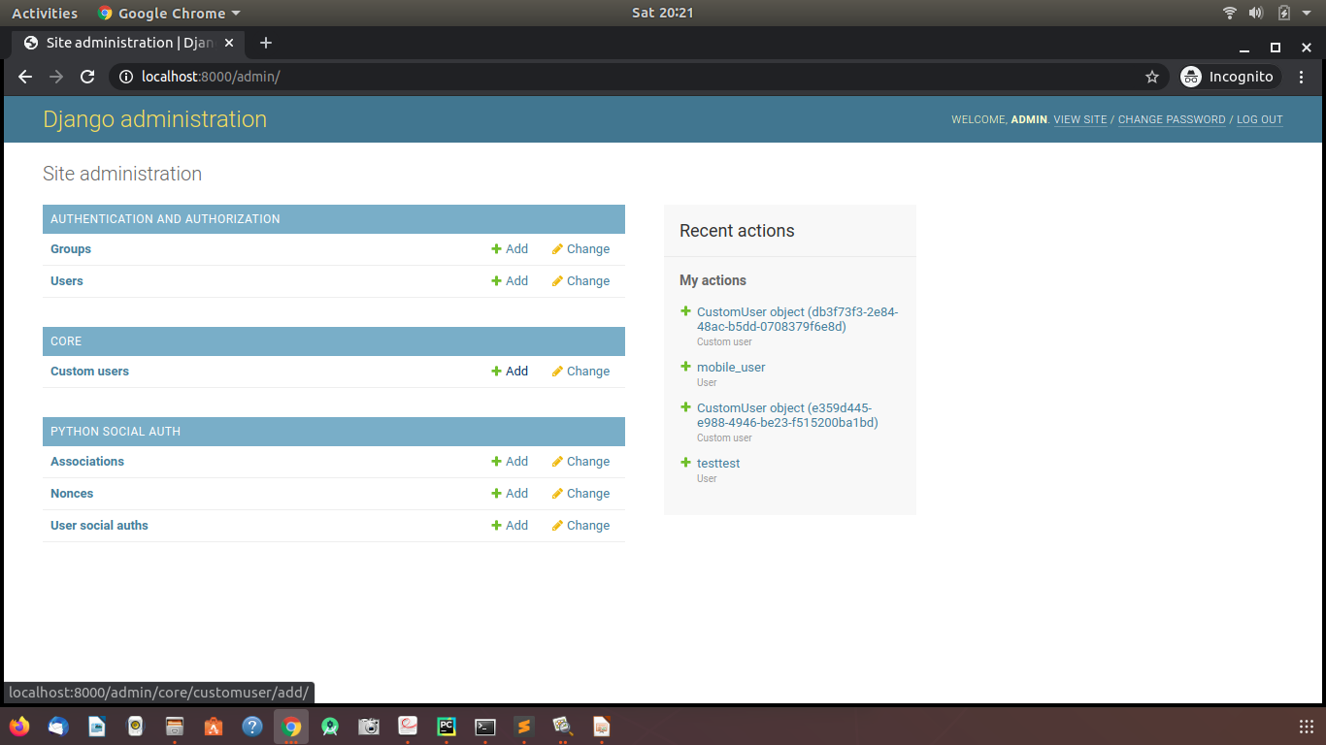

Queries:

1) Authentication happening through Social platforms then why Password updation required?

2)If password update is available then login using credentials, register user should be there?

Pending Tasks:

1)Merging all plaform logins using mobile number.

2)Change password if required